Exercise 2:
E-commerce Platform Search Function

1.Understand the Problem:
Big O notation and how it helps in analyzing algorithms.
Big O notation is the language engineers use to describe how an algorithm's execution time or memory usage grows as the amount of data increases. It completely strips away hardware differences, like how fast your specific CPU is, and looks purely at the mathematical scaling. At the end of the day, we just care about the dominant trend—whether doubling your inventory is going to double your search time, or barely affect it at all.

best, average, and worst-case scenarios for search operations.
Search Operation Scenarios When analyzing search algorithms, we look at three realities:
- Best-Case Scenario: You get incredibly lucky. The item you are searching for is the very first thing the algorithm checks.
- Worst-Case Scenario: You have the worst luck possible. The item is the very last thing the algorithm checks, or it does not exist in the database at all. This is what Big O primarily measures.
- Average-Case Scenario: Statistically, this is what happens on a normal day. The item is found somewhere in the middle of the dataset.

2. Setup:
We will implement this in Java. We need a Product blueprint, and a SearchEngine that contains our two distinct algorithms. We will assume we are searching by productId
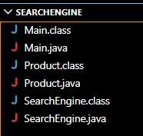

3.Implementation:
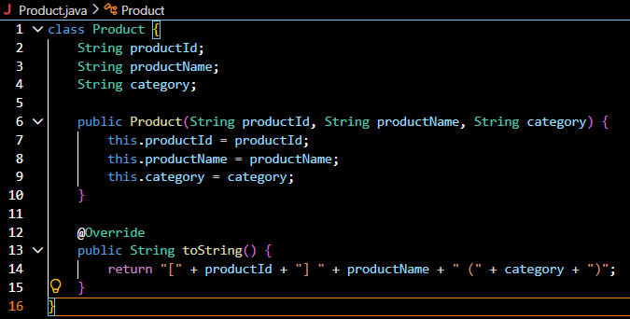
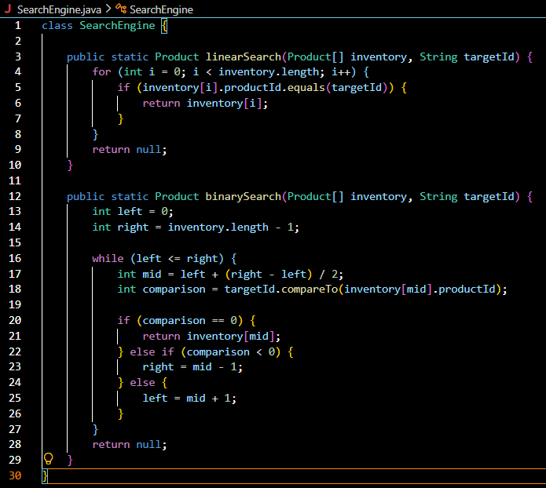
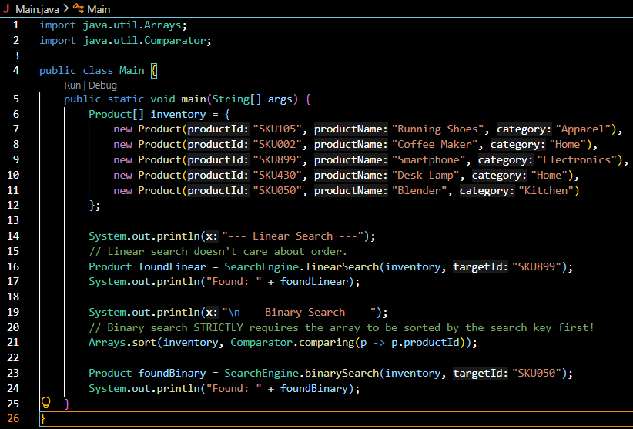
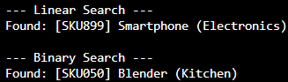

4.Analysis:
Algorithm Best-Case Average-Case Worst-Case (Big O)
Linear Search O(1) O(n) O(n)
Binary Search O(1) O(log n) O(log n)
If you have one million products, a linear search might force the computer to check all 1,000,000 items one by one in the worst case. A binary search cuts the remaining data in half with every single step, meaning it takes a maximum of just 20 checks to find an item in that same million-product inventory.
For an e-commerce platform, binary search is the superior choice. These platforms are "read-heavy," meaning thousands of customers are constantly searching for items, while updates from warehouse staff happen less frequently.
The only catch is that binary search requires the data to be perfectly sorted, which costs time behind the scenes. While a linear search allows you to add new products instantly without sorting, it ruins the search experience for your users. Ultimately, it is well worth taking the extra processing hit to keep the database sorted so that customers get lightning-fast search results.

